Unit 3 Area of Study 3 Australia and the international economy – Section B structured questions

MARK SCHEME

Question 1 (8 marks)

a. Explain two gains from international trade.
4 marks
1 mark x 2 for accurate but limited explanation a gain from international trade
2 marks x 2 for accurate and detailed explanation a gain from international trade

Gains listed in study design: lower prices, greater choice, access to resources, economies of scale, and increased competition and efficiency.

b. Identify and explain two factors that can influence Australia’s international competitiveness.
4 marks
1 mark x 2 for accurate identification of factors and limited explanation of how they would improve international competitiveness.
2 marks x 2 for accurate identification of factors and detailed explanation of how they would improve international competitiveness.

Factors: productivity, production costs, availability of natural resources, exchange rates and relative rates of inflation

Note: student must show good understanding of what an improvement in international competitiveness means.

Question 2 (7 marks)
Consider the following hypothetical data for the Australian economy.

Australia
 | XPI | MPI
2022 | 100 | 100
2023 | 98 | 102

a. Calculate the terms of trade for country X.
1 mark
TOT = XPI/MPI x 100 = 98/102 x 100 = 96
TOT = 96 (unfavourable movement)

b. Identify whether this was a favourable or unfavourable movement in the terms of trade, and explain one factor that could have caused this movement.
3 marks
1 mark for identifying it as an unfavourable movement as the average price of imports as measured by the MPI has increased relative to the average price of Australia’s exports as measured by the XPI.
1 mark for accurate explanation of the factor explaining the movement.

Factors:
- decrease in commodity prices caused by change in global demand or global supply of commodities leading to decrease in XPI
- increase in production costs of Australia’s main trading partners leading to increase in MPI

c. Explain the effect that this movement in the terms of trade would have on one macroeconomic goal.
3 marks
1 mark for accurate definition of goal

1 mark for accurate explanation of how the unfavourable movement will decrease aggregate demand.

1 mark for accurate linking to one of the macroeconomic goals of low inflation, SSEG or full employment
Question 3 (4 marks)
Consider the following hypothetical data for the Australian economy.
 | $Billions
Foreign direct investment | -100
Balance of merchandise trade | 320
Net Secondary income | -40
Financial derivatives | 60
Net Other investments | 60
Net Primary income | -180
Net Reserve assets | -140
Net services | 30
Capital account | -10

a. Calculate the balance on the current account.
1 mark
320 + 30 -180 - 40 = $130B surplus

b. Calculate the overall balance of payments.
1 mark
CAFA + CA = 0

c. Explain one possible cyclical reason for the current account balance.
2 marks
1 mark for accurate reason identified and explained in simple terms

2 marks for detailed explanation of cyclical reason for surplus, including optimal terminology (credits/debits, section of CA)

Possible reasons:

- depreciating of the exchange rate increasing value of credits from exports, decreasing value of debits from imports
- favourable movement in the terms of trade, increasing credits from export revenue
- lower consumer confidence, decreasing spending on imports
- lower disposable income due to contractionary phase of business cycle, decreasing import spending
- increase in economic growth overseas, increasing value of credits from exports

note: a student needs to give a reason that addresses BOGS not income, as in the table the primary and secondary income are still in deficit.

Question 4 (6 marks)
$AUD against the $USD
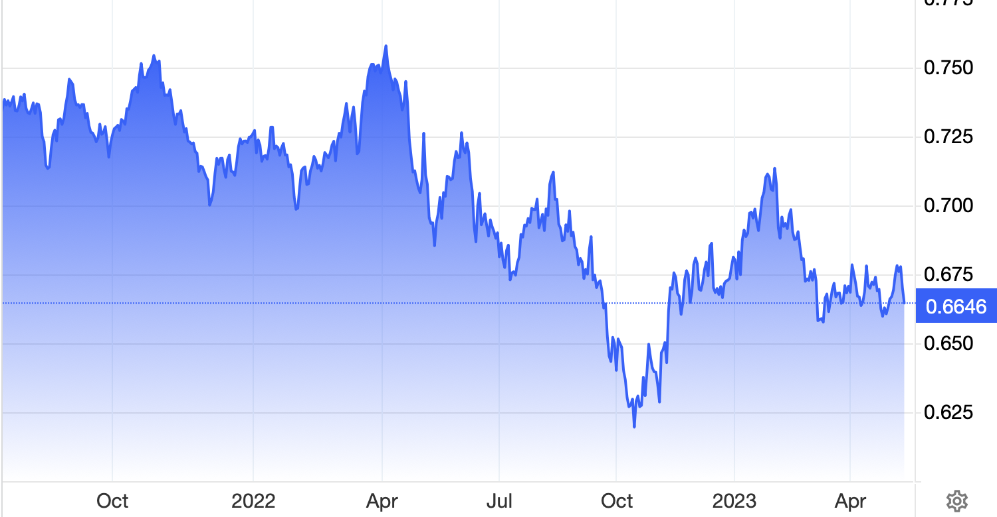

a. Referring to the data, identify and explain two possible causes for the trend in the exchange rate.
4 marks
1 mark x 2 for accurate identification of factors and limited explanation of would depreciate the value of the $AUD
2 marks x 2 for accurate identification of factors and detailed explanation of how they would depreciate the value of the $AUD

Possible causes:

- decrease in relative interest rates – increase supply of AUD
- decrease in commodity prices and unfavourable movement in terms of trade – decrease in demand for AUD
- decrease in demand for exports and increase in demand for imports – decrease demand and increase supply of AUD
- Decrease in foreign investment – decrease in demand of AUD
- Increase in relative rates of inflation – decrease in demand of AUD (decrease X) and increase in supply of AUD (increase M)
- Decrease in Australia’s credit rating - decrease in demand for AUD
- Speculation that $AUD will depreciate in the future against $USD – increase in supply of AUD

b. Explain the effect that this movement in the exchange rate could have on material and non-material living standards.
2 marks
1 mark for accurate link to material living standards (referring to an increase in households access to goods and services)

MLS links:

- Depreciation will increase x-m, AD and real GDP per capita.
- Deprecation will increase x-m, AD, real GDP and real income levels.
- Depreciation will increase x-m, AD and reduce cyclical unemployment.
- Links to AS also acceptable if explained correctly

1 mark for accurate link to material living standards (referring to an increase in general wellbeing and quality of life.

NMLS links

- Depreciation will (through increase in AD) increase in employment levels, increasing people’s sense of purpose, relieve financial stress and improve socialisation.
- Depreciation will increase AD, growth and increase taxation collected by the government which will allow them to increase provision of essential services such as education and healthcare, improving the wellbeing of households

